PreACT 8/9 and PreACT Readiness Levels and Benchmarks
Use with Connected Progress Tracker
(Readiness Ranges for PreACT 8/9, 10 and ACT as outline found in Technical Manuals at https://success.act.org)

The PreACT 8/9 can be used to monitor students’ progress towards college and career readiness. PreACT 8/9 scores are classified into one of three readiness levels:
1. On Target. Students scoring in this range are predicted to meet or exceed the ACT College Readiness Benchmark in 11th or 12th grade. The PreACT 8/9 Readiness Benchmark is the score associated with a 50% chance of meeting the ACT College Readiness Benchmark in 11th or 12th grade and is the minimum score of the On Target range.
2. On the Cusp. Students scoring in this range have less than a 50% chance, but greater than a 25% chance, of meeting the meeting the ACT College Readiness Benchmark.
3. In Need of Intervention. Students scoring in this range have less than a 25% chance of meeting the meeting the ACT College Readiness Benchmark.
PreACT 8/9 Readiness Levels are specific to grade level (8 or 9) and season (Fall or Spring), resulting in four sets of readiness levels for each PreACT 8/9 subject (English, Math, Reading, Science, and STEM). The scale score ranges for the PreACT 8/9 Readiness Levels that were derived in spring 2020 are listed in Table 3.2.
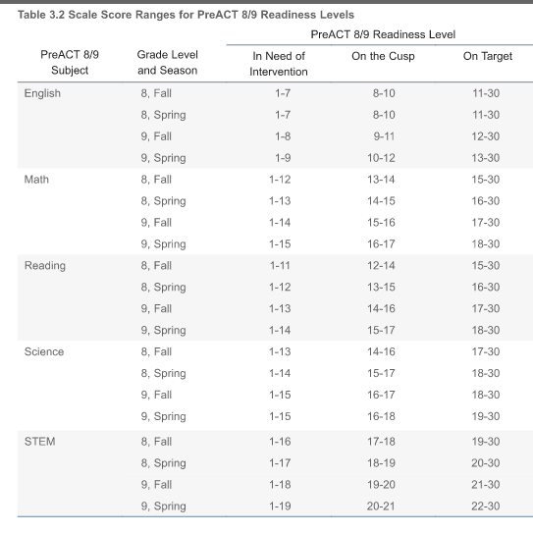

The PreACT can be used to monitor students’ progress towards college and career readiness. PreACT scores are classified into one of three readiness levels:
1. On Target. Students scoring in this range are predicted to meet or exceed the ACT College Readiness Benchmark in 11th or 12th grade. The PreACT Readiness Benchmark is the score associated with a 50% chance of meeting the ACT College Readiness Benchmark in 11th or 12th grade and is the minimum score of the On Target range.
2. On the Cusp. Students scoring in this range have less than a 50% chance, but greater than a 25% chance, of meeting the ACT College Readiness Benchmark.
3. In Need of Intervention. Students scoring in this range have less than a 25% chance of meeting the ACT College Readiness Benchmark.
PreACT Readiness Levels are specific to grade level (9, 10, or 11) and season (Fall or Spring for grades 9 and 10, Fall for grade 11), resulting in five sets of readiness levels for each PreACT subject (English, Math, Reading, Science, and STEM). The scale score ranges for the PreACT Readiness Levels that were derived in spring 2020 are listed in Table 8.2.
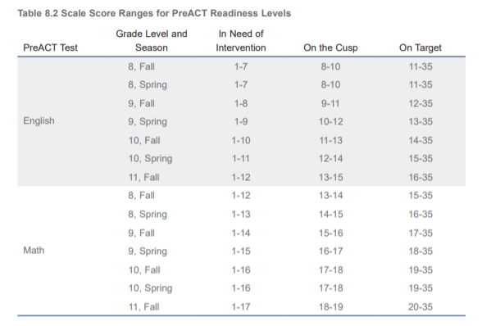

- Continued -
